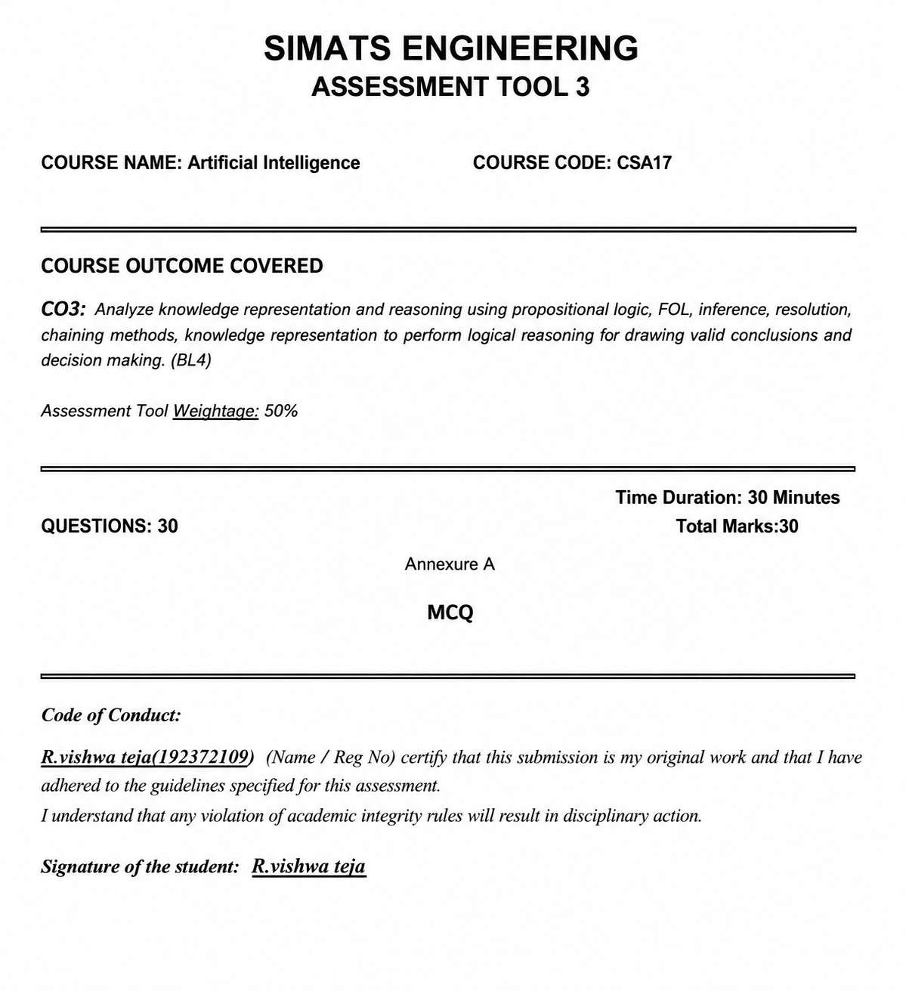

Q1. Which of the following best describes a Logical Agent in AI?
a) An agent that reacts randomly to the environment
b) An agent that uses a knowledge base and logical inference to decide actions
c) An agent that only follows pre-defined scripts
d) An agent that learns from rewards
Correct Answer: b) An agent that uses a knowledge base and logical inference to decide actions
Explanation: A logical agent uses stored knowledge and inference rules to derive conclusions and choose actions.

Q2. In Propositional Logic, 'P → Q' is logically equivalent to:
a) P ∧ ¬Q
b) ¬P ∨ Q
c) ¬Q → ¬P only
d) Both b and c
Correct Answer: d) Both b and c
Explanation: P → Q is equivalent to ¬P ∨ Q and also to its contrapositive ¬Q → ¬P.

Q3. Conjunctive Normal Form (CNF) requires the formula to be expressed as:
a) A disjunction of conjunctions
b) A conjunction of disjunctions (clauses)
c) A conjunction of literals only
d) A sequence of implications
Correct Answer: b) A conjunction of disjunctions (clauses)
Explanation: CNF is an AND of clauses, where each clause is an OR of literals.

Q4. In FOL, the sentence ∀x: Student(x) → Passes(x) means:
a) Some students pass
b) Every entity that is a student passes
c) If something passes, it is a student
d) There exists at least one student who passes
Correct Answer: b) Every entity that is a student passes
Explanation: The universal quantifier ∀x means the rule applies to every entity x.

Q5. Unification in FOL is the process of finding substitutions that:
a) Convert clauses to CNF
b) Make two logical expressions syntactically identical
c) Prove a goal using backward chaining
d) Derive facts using Modus Ponens
Correct Answer: b) Make two logical expressions syntactically identical
Explanation: Unification finds substitutions for variables so that two expressions match exactly.

Q6. In the Resolution algorithm, deriving the empty clause □ indicates:
a) The knowledge base is consistent
b) The negated goal is satisfiable
c) A contradiction — the original goal is proven
d) More clauses need to be added
Correct Answer: c) A contradiction — the original goal is proven
Explanation: In resolution refutation, deriving □ means the KB plus the negated goal is contradictory, so the goal follows.

Q7. Forward Chaining is best described as a ________ strategy.
a) Goal-driven / top-down
b) Data-driven / bottom-up
c) Heuristic-based depth-first
d) Probabilistic inference
Correct Answer: b) Data-driven / bottom-up
Explanation: Forward chaining starts with known facts and repeatedly applies rules to derive new facts.

Q8. Backward Chaining begins reasoning from:
a) All known facts toward a conclusion
b) The goal and works backward to verify supporting facts
c) A random clause in the knowledge base
d) The resolution refutation tree
Correct Answer: b) The goal and works backward to verify supporting facts
Explanation: Backward chaining starts with a goal and searches for rules and facts that can support it.

Q9. Which step is NOT part of converting a sentence to CNF?
a) Eliminate biconditionals (↔)
b) Move negations inward using De Morgan’s laws
c) Apply Skolemization to remove existential quantifiers
d) Distribute AND over OR
Correct Answer: c) Apply Skolemization to remove existential quantifiers
Explanation: Skolemization is used in FOL conversion, but it is not a standard step for propositional CNF conversion.

Q10. Knowledge Engineering in FOL involves:
a) Training a neural network on domain-specific data
b) Defining domain concepts, relations, and axioms formally in FOL
c) Writing heuristic search strategies
d) Encoding reward functions for reinforcement learning
Correct Answer: b) Defining domain concepts, relations, and axioms formally in FOL
Explanation: Knowledge engineering builds a formal representation of domain knowledge using concepts, relations, and rules.

Q11. Modus Ponens states: If P → Q is known and P is true, then:
a) ¬Q is true
b) Q must be true
c) P is uncertain
d) The KB is inconsistent
Correct Answer: b) Q must be true
Explanation: Modus Ponens directly derives Q from P → Q and the fact P.

Q12. The Most General Unifier (MGU) is the substitution that:
a) Is the most specific possible match
b) Makes two terms identical with minimal variable binding
c) Eliminates all variables from a clause
d) Applies resolution to produce CNF
Correct Answer: b) Makes two terms identical with minimal variable binding
Explanation: The MGU makes expressions identical while imposing the least specific necessary substitutions.

Q13. Which inference method is more appropriate when a specific goal is known?
a) Forward Chaining
b) Truth Table method
c) Backward Chaining
d) A* search
Correct Answer: c) Backward Chaining
Explanation: Backward chaining is goal-driven, so it is suitable when a specific conclusion must be verified.

Q14. Propositional Logic differs from First Order Logic because it:
a) Supports probabilistic reasoning
b) Cannot represent objects, relations, or quantifiers — only truth values of atomic propositions
c) Is always more expressive
d) Handles uncertainty better
Correct Answer: b) Cannot represent objects, relations, or quantifiers — only truth values of atomic propositions
Explanation: Propositional logic represents propositions as true or false, while FOL can represent objects, relations, and quantifiers.

Q15. Resolution Refutation proves a goal G by:
a) Directly deriving G from the KB using forward chaining
b) Adding ¬G to the KB and deriving a contradiction (empty clause □)
c) Checking G in the truth table
d) Applying Modus Tollens repeatedly
Correct Answer: b) Adding ¬G to the KB and deriving a contradiction (empty clause □)
Explanation: Resolution refutation negates the goal and derives the empty clause to show that the negation is impossible.

Q16. Learning from observation in AI refers to:
a) An agent receiving numerical rewards from the environment
b) Improving performance by examining examples or experience from the environment
c) Acquiring knowledge by following explicit symbolic rules
d) Memorizing a fixed dataset without generalization
Correct Answer: b) Improving performance by examining examples or experience from the environment
Explanation: Learning from observation means improving behavior or knowledge from examples and environmental experience.

Q17. Inductive learning is best described as:
a) Deriving specific conclusions from general rules
b) Generalizing a hypothesis from specific training examples
c) Memorizing training data exactly
d) Applying search algorithms to find optimal policies
Correct Answer: b) Generalizing a hypothesis from specific training examples
Explanation: Inductive learning moves from specific examples to a generalized hypothesis.

Q18. In a Decision Tree, what does each internal node represent?
a) A class label / output decision
b) A probability distribution over outcomes
c) A test on an attribute / feature
d) A training data sample
Correct Answer: c) A test on an attribute / feature
Explanation: Each internal node tests an attribute or feature and branches according to its possible values.

Q19. Explanation-Based Learning (EBL) differs from inductive learning because it:
a) Requires large amounts of training data to generalize
b) Learns only from numeric data using regression
c) Uses prior domain knowledge to explain and generalize a single example
d) Applies unsupervised clustering to find hidden patterns
Correct Answer: c) Uses prior domain knowledge to explain and generalize a single example
Explanation: EBL uses existing domain knowledge to explain why an example works and generalizes that explanation.

Q20. In statistical learning, a Naive Bayes classifier assumes:
a) All features are conditionally dependent on each other given the class
b) The data must follow a uniform distribution
c) All features are conditionally independent given the class label
d) Labels are determined by a reward function
Correct Answer: c) All features are conditionally independent given the class label
Explanation: Naive Bayes assumes conditional independence among features when the class is known.

Q21. Learning with complete data (no hidden variables) in a Bayesian network involves:
a) Using the EM algorithm to estimate missing values
b) Training a deep neural network with dropout regularization
c) Directly computing maximum likelihood estimates from observed data
d) Applying reinforcement signals to update weights
Correct Answer: c) Directly computing maximum likelihood estimates from observed data
Explanation: With complete observed data, parameters can be estimated directly using maximum likelihood.

Q22. The Expectation-Maximization (EM) algorithm is used when:
a) Training data is fully labeled and no variables are hidden
b) An agent explores an unknown environment using trial and error
c) The dataset contains hidden (latent) variables that cannot be directly observed
d) Backpropagation fails to converge in a neural network
Correct Answer: c) The dataset contains hidden (latent) variables that cannot be directly observed
Explanation: EM alternates between estimating hidden variables and updating model parameters.

Q23. In a Neural Network, the activation function serves to:
a) Initialize the weights of each neuron to zero
b) Normalize the input dataset before training
c) Introduce non-linearity to enable learning of complex patterns
d) Store previously learned examples in memory
Correct Answer: c) Introduce non-linearity to enable learning of complex patterns
Explanation: Activation functions add non-linearity, allowing neural networks to model complex relationships.

Q24. Which of the following correctly describes backpropagation in a neural network?
a) Weights are updated in the forward pass using input gradients
b) Outputs of each layer are stored and reused in later epochs
c) The error is propagated backward from output to input layers to adjust weights
d) A separate model is trained for each hidden layer independently
Correct Answer: c) The error is propagated backward from output to input layers to adjust weights
Explanation: Backpropagation calculates error gradients backward through the network and uses them to update weights.

Q25. A Support Vector Machine (SVM) — a type of kernel machine — classifies data by:
a) Minimizing the number of training examples used
b) Grouping similar data points into clusters using centroids
c) Finding the maximum-margin hyperplane that separates classes
d) Updating weights using Q-values from an environment
Correct Answer: c) Finding the maximum-margin hyperplane that separates classes
Explanation: SVM seeks a decision boundary with the maximum margin between classes.

Q26. The kernel trick in kernel machines (SVMs) allows:
a) Reducing the number of support vectors needed
b) Accelerating gradient descent convergence
c) Operating in a high-dimensional feature space without explicitly computing coordinates
d) Replacing hidden layers in a deep neural network
Correct Answer: c) Operating in a high-dimensional feature space without explicitly computing coordinates
Explanation: The kernel trick computes similarity in an implicit high-dimensional feature space without explicitly mapping each point.

Q27. In Reinforcement Learning, the agent aims to maximize:
a) Classification accuracy on a fixed test set
b) The number of features selected from the training data
c) Cumulative reward received over time through interaction with the environment
d) The size of the neural network hidden layer
Correct Answer: c) Cumulative reward received over time through interaction with the environment
Explanation: The objective of reinforcement learning is to maximize long-term cumulative reward.

Q28. The Q-Learning algorithm in Reinforcement Learning is classified as:
a) A supervised learning algorithm requiring labeled datasets
b) An unsupervised clustering technique using centroids
c) A model-free, off-policy temporal difference learning method
d) A decision-tree-based ensemble classifier
Correct Answer: c) A model-free, off-policy temporal difference learning method
Explanation: Q-learning learns action values directly from interaction without requiring an explicit environment model and follows an off-policy TD approach.

Q29. Overfitting in machine learning occurs when:
a) The model performs poorly on both training and test data
b) The learning rate is set too low during gradient descent
c) The model fits training data too closely and generalizes poorly to new data
d) The training set has more features than training examples
Correct Answer: c) The model fits training data too closely and generalizes poorly to new data
Explanation: An overfit model memorizes training patterns/noise and performs poorly on unseen data.

Q30. Which of the following best distinguishes Reinforcement Learning from Supervised Learning?
a) RL uses labeled input-output pairs; SL uses reward signals
b) Both RL and SL require explicit reward functions
c) RL learns via trial-and-error with reward feedback; SL learns from labeled examples
d) RL is always faster to converge than SL on any dataset
Correct Answer: c) RL learns via trial-and-error with reward feedback; SL learns from labeled examples
Explanation: RL learns through interaction and rewards, whereas supervised learning learns from labeled input-output examples.

